AFNR Teacher/FFA Advisor
School Name
School Address
Town, State Zip Code
Phone Number

Juleah Tolosky
Executive Director
Minnesota FFA Association
PO Box 130354
Roseville, MN 55113

Dear Ms. Tolosky:

We, the undersigned, affirm that the Agriculture, Food, and Natural Resources (AFNR) students of Type School Name Here have organized into a local chapter and are applying for membership in the Minnesota FFA Association. In the name of the chapter and for the chapter, we hereby make application for a charter that will give full membership in the National FFA Organization and the Minnesota FFA Association. We have adopted a constitution and bylaws that is consistent with the Minnesota FFA Constitution, elected necessary officers, identified membership and developed a preliminary Program of Activities.

The official chapter name should appear on the charter as Insert FFA Chapter Name Here FFA Chapter (eg. Kimball, St. Paul – Como Park). We agree to adhere to Article III of the National FFA Constitution which states:
Chapters of the National FFA Organization shall be chartered only in such schools where recognized systematic instruction in agricultural education is offered under the provisions of federal vocational education legislation. Such chapters shall operate as an integral part of the instructional program of agricultural education.

We understand that FFA is an intracurricular component of AFNR education. Our school has a certified/licensed teacher(s) delivering instruction for a Minnesota Department of Education recognized and approved program of AFNR within Career and Technical Education serving the AFNR Career Cluster. The AFNR teacher(s) shall be the FFA advisor(s) in accordance with the National FFA Constitution’s Article X.

Our chapter shall be in good standing with the state association when the following conditions, as outlined in Article IV of the National FFA Constitution, are met:
- All annual, state, and national dues or program affiliation fees have been paid by the date determined by the state association.
- All reports have been submitted as requested by the state association.
- Provisions of the chapter constitution do not conflict with the State or National FFA Constitutions and chapter activities are in harmony with the ideals and purposes of the National FFA Organization.

Attached to this application, completed with accurate information, are the following documents:
- A list of chapter officers;
- A complete list of chapter members;
- A copy of the chapter’s constitution and bylaws;
- A copy of our preliminary Program of Activities (calendar of events and strategic plan); and
- The chapter Charter Application and Agreement.

We hereby make application for a charter in the Minnesota FFA Association of the National FFA Organization.

Sincerely,

_____________________________________
Date Organized Chapter President Signature

_____________________________________
Chapter Secretary Signature

_____________________________________
Chapter Advisor Signature

_____________________________________
School Administrator Signature/Title

*Sample FFA Program of Activities and Constitution & Bylaws can be found on the
“Chapter Resources” page of www.mnffa.org.

Chapter Information:
For State Office Use Only:

Chapter Number: MN______________
School Name:
Billing Address:
City: State: Zip:
Shipping/Physical Address:
City: State: Zip:
School Phone:

Official FFA Chapter Name:
Program Type: High School Middle School Middle/High School
Select all grades in which AFNR will be taught: 7th 8th 9th 10th 11th 12th
Unduplicated AFNR Enrollment:

Lead Advisor’s Information:
Advisor’s Name:
Advisor’s Email Address:
AFNR Department Phone:
Advisor’s Mobile Phone:

Additional Advisor’s Information:
Advisor’s Name:
Advisor’s Email Address:
AFNR Department Phone:
Advisor’s Mobile Phone:

Principal’s Information:
Principal’s Name:
Principal’s Email Address:
Principal’s Phone:

Type of Membership: Program Affiliation (all students are members) Individual Member Dues

Official FFA Jacket Information:
On the back of the jacket “Minnesota” will be listed as the state name above the emblem.
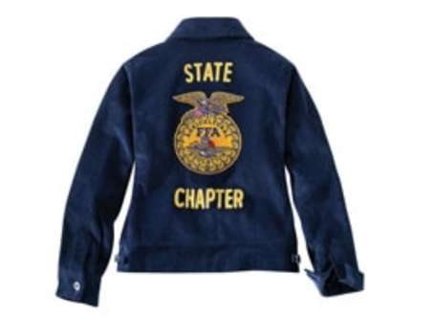
Please give the chapter name (up to 2 lines) that will appear below the emblem.
Jacket Back: Chapter Name Line 1:
Jacket Back: Chapter Name Line 2:
(if applicable)

Please include four items with your application:
- A list of chapter officers (submit by March 1);
- A complete list of chapter members;
- A copy of the chapter’s constitution and bylaws; and
- A copy of the chapter’s preliminary Program of Activities (or link to the AET calendar/POA).

