
Using The AET to Submit to FFA.org

Purpose: To help export student accounts directly into the National FFA Roster System and correctly record a student’s FFA number.

Step 1: Manage Your Student Accounts
A. Log in as the teacher and choose ACCOUNTS and Manage All Accounts. Review your list of students to make sure all FFA members are listed and recently logged in and completed their profile. (See Teacher Help & Managing Student Accounts Guide/Video)

Step 2: Review Student Information and Submit to FFA for Membership
(In AET ACCOUNTS, “FFA Roster Helper”).
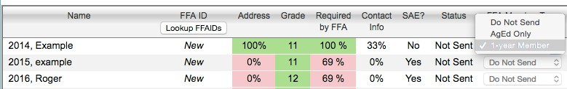

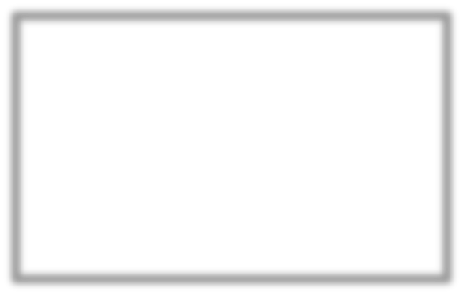

- Areas in “Red” are missing information required by FFA. Areas in “Green” are complete. All students with a complete profile can be set as “1-­year Member” or “Ag Education Only” or “Do Not Send”.

- Any areas shaded in “Red” are state and national requirements for FFA membership (see instructions). You can review/edit student information by selecting any area:
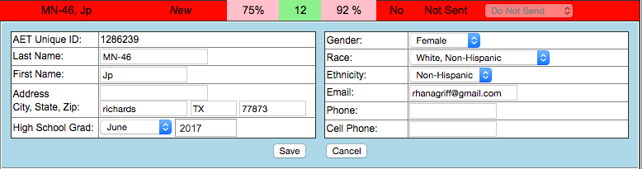



- Sending members to FFA is accomplished by: Send MEMBERS or Send CHECKMARKED!
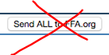

  - “Send MEMBERS to FFA.org” – send only those marked as “1-­year Members”
  - “Send CHECKMARKED to FFA.org” – will send the students checked on this page
**DO NOT CHOOSE “Send ALL to FFA.org” -­ sends all “1-­year Member” & “Ag Ed Only” students. It creates membership numbers for every student you send and leads to the MN FFA Numbers being off! Please DO NOT CHOOSE this.

Step 3. Review Membership “Status”
The “Status” column reports the progress of new or updated membership. Allow time to process membership and return to this screen to review their status. This is a local submission, go to FFA.org and review for a final submit to “State”.
Step 4. New Members Arrive – Simply repeat the above processes for the new member and submit to FFA.org in the same manner, but only the new members will be submitted.

