

Agriculture, Food, and Natural Resources (AFNR) Frameworks 2021

## Preface: Introduction

### Three Component Model of School-Based AFNR Education

**Classroom and Laboratory Instruction—Academic Skill Development—**Contextual project-, problem-, and inquiry-based instruction through classroom and laboratory settings such as a school greenhouse, farm, or natural resources lab. Advanced inquiry-based curricula known as Curriculum for Agricultural Science Education (CASE; cf. Project Lead The Way) is available through the National Council for AFNR Education (The Council).

**Supervised Agricultural Experience (SAE)—Technical Skill Development and Work-Based Learning—**A student-led, instructor-supervised, Work-Based Learning (WBL) experience that results in measurable outcomes within a predefined, agreed upon set of AFNR Technical Standards and Career Ready Practices aligned to a Career Plan of study. SAE teaches technical skills and knowledge within the psychomotor domain of learning. SAE includes both experiential learning (i.e., pre-WBL) and WBL (federally defined as sustained interactions with industry or community professionals in real workplace settings, to the extent practicable, or simulated environments, at an educational institution that foster in-depth, firsthand engagement with the tasks required in a given career field, that are aligned to curriculum and instruction; Sec. 3 [20 U.S.C. 2302] 55).

**The National FFA Organization (FFA)—Social Emotional Skill Development and Student Leadership—**A student-led, instructor-supervised, Career and Technical Student Organization (CTSO) that results in measurable outcomes within a predefined, agreed upon set of AFNR social-emotional standards and Career Ready Practices aligned to a Career Plan of study. FFA teaches social-emotional and leadership skills and knowledge within the affective domain of learning. FFA includes programs that teach essential employability skills such as critical thinking, communication, and leadership. FFA was founded in 1928 and is federally defined as intracurricular (within the curriculum; cf. extracurricular: external, co-curricular: alongside) and an integral (necessary to form the whole) component of School-Based AFNR Education (Public Law No. 116-7).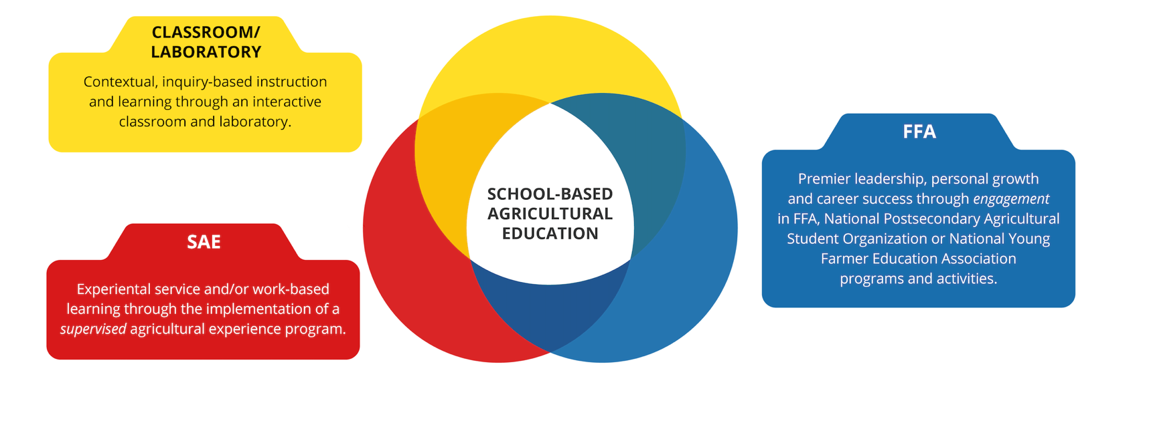

### Purpose

Just as the industries of agriculture and natural resources vary throughout our state, nation, and around the world, so too will our School-Based AFNR Education programs. While academic standards in math, science, language arts, and social studies are set at the state level, each district in Minnesota must establish, align, revise, and review its own standards in career and technical education (Minn. § 120B.022, Subd. 1; Minn. § 120B.021, Subd. 4, d). To aid with setting local standards within AFNR, the Minnesota Department of Education has aligned and adapted the National AFNR Career Cluster Content Standards, to create the Minnesota AFNR Standards and Frameworks. Local entities are encouraged to adapt the standards to meet the needs of their community, AFNR industry sector, and local needs. Districts should use the standards within this document as a framework or guide for the development of well-planned curricula and assessments for AFNR Career and Technical Education (CTE) programs, in conjunction with local advisory committees to decide what is most relevant and right for their students in providing that all-important link between the school and the AFNR business community. These standards help shape the design of each of the three intracurricular (within the curriculum; cf. extracurricular: external, co-curricular: alongside) and integral (necessary to form the whole) components School-Based AFNR Education (Public Law No. 115-224; Public Law No. 116-7; Minn. R. 3505).

AFNR is a highly technical and ever-changing sector of the global economy upon which everyone is dependent. We will continue to meet national and global demand for a safe and abundant food, fiber, and fuel supply if we invest in the growth and development of students pursuing careers in AFNR. Strong, relevant AFNR CTE programs that are informed by industry and education stakeholders are one way we can meet workforce needs now and in the future. The AFNR Career Cluster Content Standards provide agriculture and natural resources teachers with a high-quality, rigorous set of standards to guide what students should know, feel, and be able to do after completing a program of study in any of the following AFNR career pathways:

* Agribusiness Systems (ABS)
* Animal Systems (AS)
* Biotechnology Systems (BS)
* Food Products and Processing Systems (FPP)
* Natural Resources and Environmental Service Systems (NRES)
* Plant Systems (PS)
* Power, Structural, and Technical Systems (PST)

The [AFNR Career Cluster Content Standards](https://www.ffa.org/thecouncil/afnr) were originally developed as part of the 2003 United States Department of Education (ED) Career Clusters Project. In 2009, and again in 2015, The Council reviewed and revised the content standards. Since its beginning in December 1983, The Council has provided leadership for stakeholders in agriculture, food, fiber, and natural resources and School-Based AFNR Education. In 2016, the CTE Unit (Perkins, Secondary Education), within the Career and College Success Division at the Minnesota Department of Education developed the AFNR curriculum frameworks. Select AFNR educators from Minnesota schools developed the statewide AFNR frameworks by aligning the AFNR Career Cluster Content Standards of The Council to Minnesota Academic Science (2009) and Economic Standards (2011), and CTE courses offered in local Minnesota districts (i.e., Minnesota Perkins Table C, AFNR Courses). In 2021 a second committee revised the frameworks to further integrate industry-wide AFNR Cluster skills, Career Ready Practices for leadership development, and Minnesota Work-Based Learning frameworks.

### Acknowledgements

The State of Minnesota commends those that provided input and assistance to this project for their leadership, thoughtful input, and dedication.

The National Association of State Directors of CTE (NASDCTE) and National CTE Foundation (NCTEF) have provided permission to for Minnesota to use the Common Career and Technical Core (CCTC) Standards in support of this project. Further, their insights and input about the revised standards has been valuable in shaping the final product. NASDCTE and NCTEF are the owners and developers of the Common Career and Technical Core (CCTC) Standards.

#### 2016

The development process relied upon input from 20 AFNR teachers and state leaders representing educators at the secondary and post-secondary level. Mr. Joel Larsen, State Supervisor of Agricultural Education at the Department of Education, managed the grant. Mr. Carl Aakre and Ms. Leah Bott worked as project directors to develop the frameworks and lead the team. The input from these educators was fundamental to achieving the project goals. Educators on the development team included:

* Mr. Carl Aakre, Curriculum for Agricultural Science Education
* Mr. Paul Aarsvold, Plainview-Elgin-Millville
* Mr. Brian Boomgaarden, Pipestone
* Ms. Leah Bott, Lake Superior (Silver Bay)
* Mr. TJ Brown, Springfield
* Ms. Darcy Dahna, Windom
* Mr. Dan Dylla, United South Central (Wells)
* Ms. Stacy Fritz, Chatfield
* Ms. Sue Gorman, Goodhue
* Ms. Angie James, St. James
* Mr. Joel Larsen, MN Dept. of Education
* Mr. Kerry Lindgren, Staples-Motley
* Mr. Jacob Oyster, Sebeka
* Mr. John Roberts, Holdingford
* Mr. Barry Schmidt, Tri City United (Montgomery)
* Mr. Paul Skoglund, Tracy
* Mr. Eric Sawatzke, Dassel-Cokato
* Mr. Tracy Tebben, New London-Spicer
* Mr. Mike Thofson, Lake Crystal-Wellcome Memorial
* Ms. Liz Tianglia, Owatonna

#### 2021

The revision process relied upon input from nine AFNR teachers and state leaders representing districts across the state and with specific content area expertise relative to each AFNR pathway. Dr. Zane Sheehan, State Supervisor of Agricultural Education at the Department of Education, managed the grant. Ms. Leah Bott, project director, and Ms. Lavyne Rada, project editor, revised the frameworks and led the team. The input from these educators was fundamental to achieving the project goals. Educators on the revision team included:

* Ms. Leah Bott, Lake Superior (Silver Bay)
* Ms. Darcy Dahna, Mountain Lake (Plant)
* Mr. Stephen Funk, Park Rapids (Natural Resources, Environmental Services)
* Mr. Mike Miron, Forest Lake (Agribusiness, WBL/SAE, FFA)
* Ms. Lisa Orren, Redwood Falls (Animal)
* Ms. Lavyne Rada, MN FFA Association
* Dr. Zane Sheehan, MN Dept. of Education
* Mr. Al Stemper, Foley (Power/Technical)
* Ms. Steph Wohluter, Martin County West (Sherburn; Food, Biotechnology)

### Structure of Standards

Within each pathway, the standards are organized as follows:

#### Standards

These are the standards set forth for each of the respective content areas outlined above in the 2012 version of the Common Career and Technical Core Standards. These statements are owned by the NASDCTE and NCTEF and are used here with permission. They define what students should know and be able to do after completing instruction in a program of study for this pathway.

#### Performance indicators

These statements distill each performance element into more discrete indicators of the knowledge and skills students should reach through a program of study. Attainment of the knowledge and skills outlined in the performance indicators is intended to show an acceptable level of proficiency with the related performance element at the conclusion of a program of study in this area.

#### Benchmarks

The statements are sample measurable activities that students might carry out to show attainment of each performance indicator at three levels of proficiency: (a) awareness, (b) intermediate, and (c) advanced. The measurements are non-exhaustive and provided as examples to show a logical progression of knowledge and skill development about content areas related to the performance indicator. Local entities may decide the proper timing for attainment of each level of proficiency based upon local CTE program structures.